Bristol Tree Forum
BRISTOL TREE OF THE YEAR 2018 APPLICATION FORM
Your organisation or group:Friends of the Downs

Contact email:info@friendsofthedowns

Contact name:Richard Bland

Details of Your Chosen Tree
Tree species:Hawthorn

Tree girth (in centimetres measured at breast height): 250 cm

Tree location* (Ideally, please use either a lat/long reading or an eight figure OS grid reference. If that is not possible, give clear directions so it can be found): situated on the Downs close to Bakers Path and Ladies Mile, at ST5686 7451

Your reasons for choosing this tree (please give any relevant details of its history and why it is important to your group): This magnificent tree is one of the last of the veteran hawthorns for which the Downs was famous in 1900. People came from miles around to see and smell the thorns when they were in bloom. Most of these fine trees have become the centres of the clumps of small trees and scrub that are now a distinctive feature of the Downs. They have become infested with Ivy, Clematis, Dog Rose, and Bramble and most have died.

A girth of 250cm for a normal tree would not indicate old age, but Hawthorns grow far more slowly that normal trees, and a growth rate of a cm a year when young will slow with age, so that a girth of 250cm suggests an age of at least 250 years. This thorn is distinctive in having a single bole, which rapidly splits into six major trunks. Many of the other veterans thorns have become multi-trunked with age which makes accurate age assessment impossible.
In bloom this tree remains magnificent.
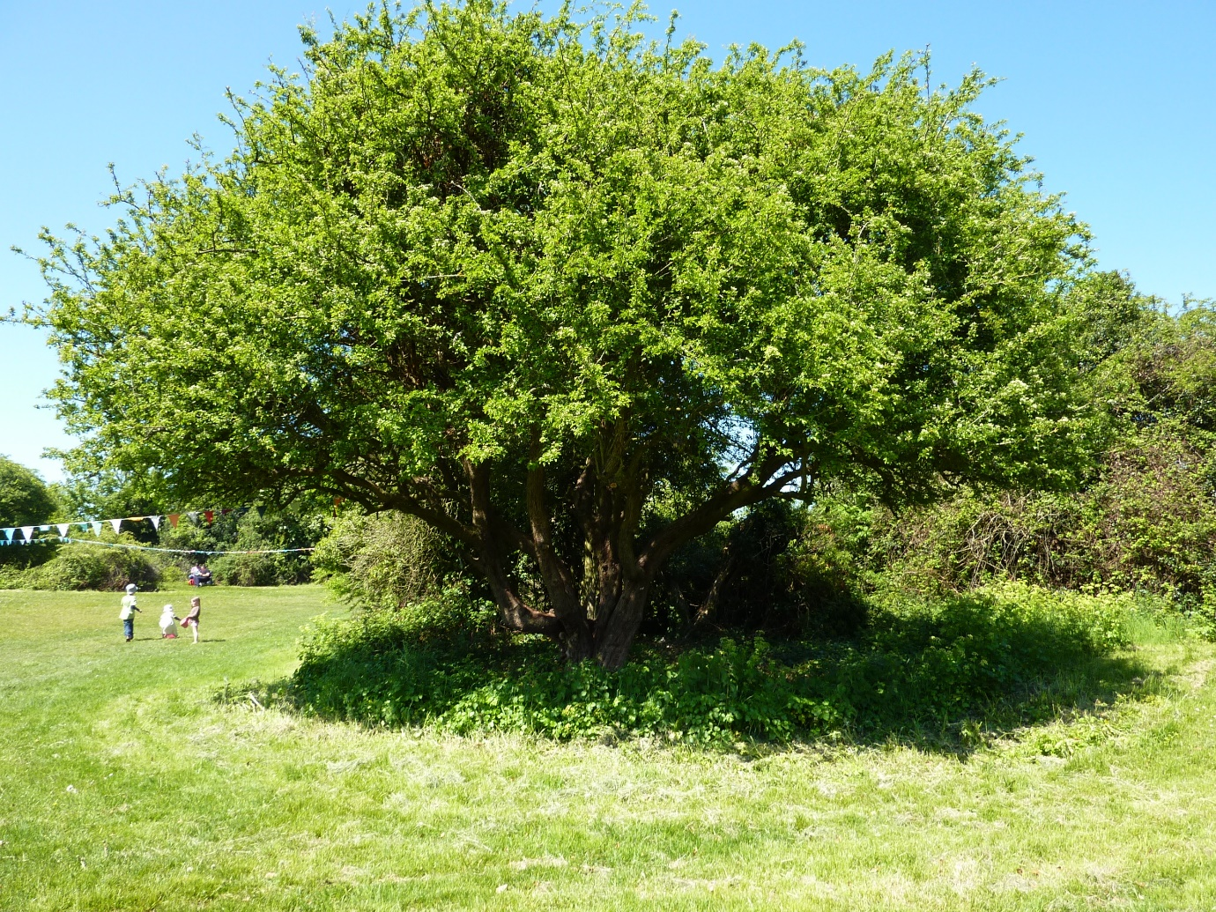

Photographs. A maximum of four photographs, perhaps in different seasons.
* It must be within the Bristol City Council Boundary and in a public space accessible by anyone.
Return your completed form to: TreeoftheYear@bristoltreeforum.org

